User Guide for Monkey Music Box

Version 1.0
Wenyi zou
August 27, 2014
Monkey Music Box Overview

This box is for the prostheticst using in prosthetic socket.

The whole box will be inside a monkey. The wire coming out will be connected to a force sensor resister. Put the sensor in to prosthetic socket. When patient try to fit the socket, with some certain pressure on sensor, the box will play sound that stored before to indicate the right fitness of patient.

Patient here especially means baby and kid.

Monkey Music Box Layout

Front side:
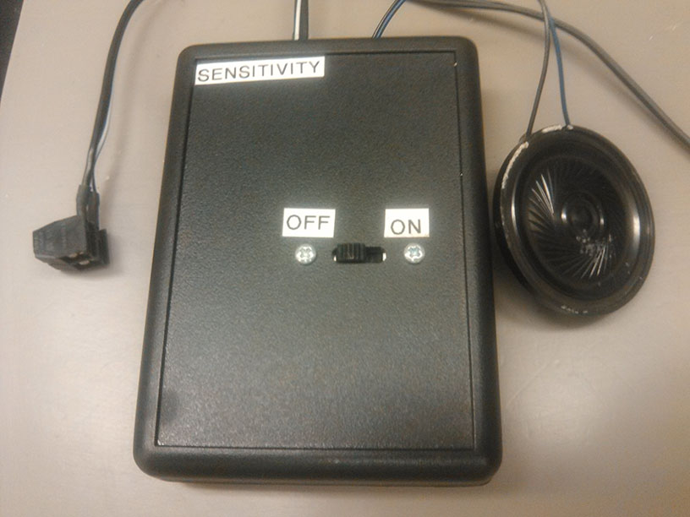
Front side contains:
- Power switch

Top side:
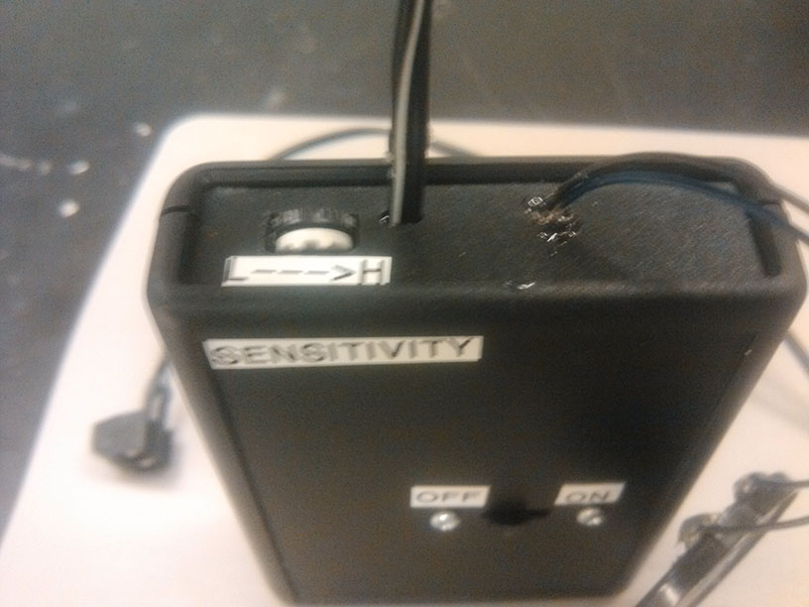
Top side contains:
- Sensitivity knob.
- Screw terminal wire.
- Speaker wire.
Back side:
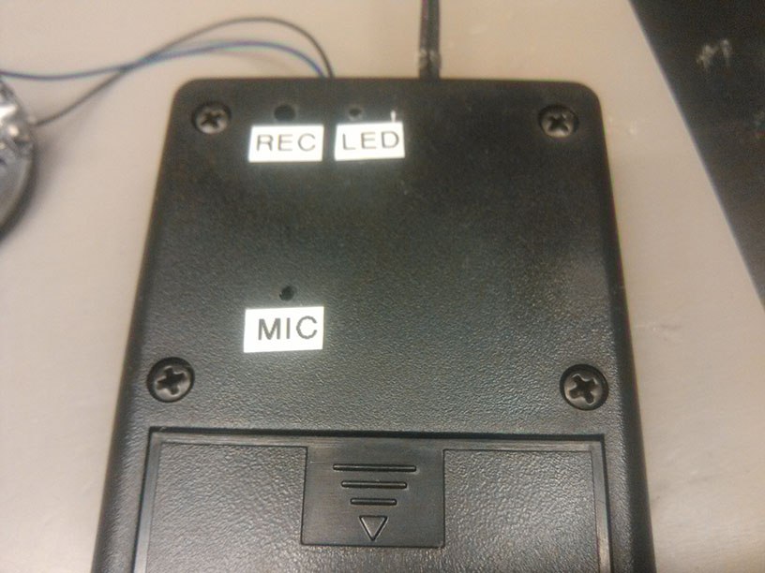
Back side contains:
- Recorder button hole.
- Led indicator hole.
- Microphone hole.
- Battery cover.

Screw terminal:
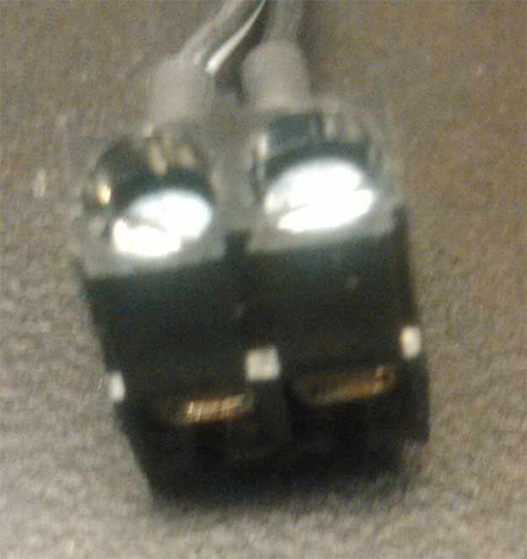
Step for Using Box

- Connect force sensor resistor(FSR) to screw terminal.
- Open battery cover, put 2 AAA batteries, close battery cover.
- Turn on the power switch.
- Press the FSR and adjust the sensitivity knob in a good position according to specific requirement, until it play sound.
- Put FSR inside prosthetic socket and use.

Note:
- When playing sound, the LED will keep blinking. And in order to play the whole sound, FSR should be press all the time without lose.
- Sensitivity knob is not a linear device, the more it get close to low sensitivity, the smaller turning is needed.
- Don’t pull the wire.

Step for Changing Sound
- Turn on the power switch.
- Use pen or some stick have similar size as REC hole, push down the inside rubber button.
- When the box is recording, the LED will keep light until release the button, which means finish record.

Note:
- Please use some stick have similar size to push, it’s not recommend to use some thin pin to push. For one aspect, it may damage the button, for the other aspect, thin pin may not totally push down the button and thus the recording will fail.
- When recording, please don’t block MIC hole.

Extra Information

The FSR and sensitivity knob is changeable. However, it should change coordinately.

For the regular FSR(From 40Mohms to 100ohms), user don’t need to change sensitivity knob, just use screw terminal to change FSR.

If user find it’s hard to set the sensitivity knob to meet the requirement, please give the box the electronic team(Suggest Michael Stephens) in RIC, let them change the sensitivity knob for you.

